User’s Manual of 3rd Generation Bluetooth Module

Product Name： 3rd Generation Bluetooth Module
Model： SOYO-BT24G03
Date： 2014-09-08
Edition： Version1.0

Soyo Technology Development Co. Ltd.

All rights reserved

Content
1.Introduction 1
2.Applications 1
3. Functions 1
3.1 Framework 1
3.2 Functions Description 1
4. Specifications 2
5. Pins Description 3
5.1 Pins Distribution 3
5.2 Pins Functions Declaration 3
6. Key Function Description 5
6.1.1 Module Power up（Starting up at 3.7-4.2V or USB power up） 5
6.1.2 PWRKEY 5
6.1.3 Mode Key 5
6.1.4 Prev / Vol-(Previous music/Previous broadcast/Volume down) 5
6.1.5 Next/Vol+(Next music/Next broadcast/Volume up) 5
6.1.6 Play/Pause(Play/Pause、Accept、Dial、Hang up) 5
6.1.7 CH(Pairing) 6
6.1.8 RESET KEY(Reset) 6
7. Module Diagram and Dimensional Drawing 6
7.1.1. Dimensional Drawing 6
7.1.2 Module Image 7
7.1.3 Pins Drawing 7
8. Reference Applications 8
9 I/O pins 9
10. PCB LAYOUT 10

1.Introduction
SOYO-BT24G03 is a highly-integrated, low-cost, low-power, single-chip Bluetooth module. It is characterized by lots of outstanding functions, such as BT call, Micro SD, FM Radio, auxiliary line-in input and suitable for stereo applications. It conforms to Bluetooth 2.1+EDR Standard.

2.Applications
- Bluetooth Wireless Audio Transmission( single track or stereo output)
- Bluetooth stereo headset
- Micro SD Reader, Bluetooth Dialer, Bluetooth Speaker etc.

3. Functions

3.1 Framework
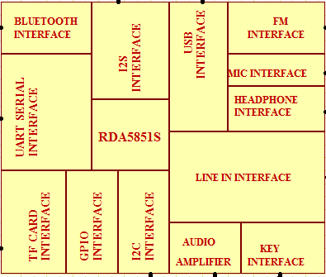

3.2 Functions Description
- Support MP3/WMA/WAV/SBC
- Bluetooth Stereo Transmission, BT call
- FM Radio Tuner
- Micro SD Controller, USB(Slave)
- Stereo Analog Auxiliary Line Input
- UART Serial Interface, Self-Customize AT Communications Protocols
- Internal Integrated Power Management Circuits
- I2S and I2C Controller
- Micro SD Program Updating
- ADC Serial Keypads+ Power on Reset Control, and Hardware Power on
- Multiple I/O Ports for additional applications
- USB Sound Adapter

4. Specifications
Bluetooth Version |  | Bluetooth V2.1_ERP
Modulation |  | PSK 3Mbps TT/4 DQPSK 和8DPSK
Profiles |  | HFP/HSP,OPP,A2DP/AVRCP,PBAP
Sensibility（0.1% BER） |  | -82dBm
Transmit Power |  | Meet Class2 and Class3 ，Max +7dbm
Voltage |  | 3.4-4.2V(Starting up $3.7-4.2V$)
Current | Normal Working | ≦60mA
Current | Standby | ≦35mA
 | Micro SD Working | ≦41mA
 | Micro SD Standby | ≦24mA
 | FM Working | ≦68mA
 | FM Standby | ≦59mA
 | AUX IN Working | ≦33mA
 | AUX IN Standby | ≦24mA
 | Shutdown | 30uA
 | Power off | 35uA
SNR |  | 65dB(50-15KHz)
Distance |  | 10m
FM Frequency Range |  | 65-108MHz
Micro SD |  | MAX 32G
Work Temperature |  | -20 to +50℃
Dimension |  | 17.51x 16.66x 0.8mm

5. Pins Description

5.1 Pins Distribution

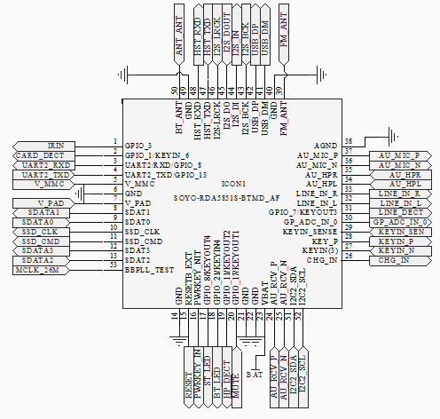

5.2 Pins Functions Declaration
Pins | Name | Description
1 | GPIO_3 | GPIO/IR Rx, Interrupt supported
2 | GPIO_1/KEYIN_6 | GPIO/Default Micro SD Detection，Interrupt Supported
3 | UART2/RXD/GPIO_8 | UART2 Serial/GPIO, no Interrupting
4 | UART2_TXD/GPIO_13 | UART2 Serial/GPIO, no Interrupting
5 | V_MMC | Micro SD Power Supply（2.98V Output）
6 | GND | Ground
7 | V_PAD | 2.98V Output
8 | SDAT1 | Micro SD Data Line
9 | SDAT0 | Micro SD Data Line
10 | SSD_CLK | Micro SD Clock
11 | SSD_CMD | Micro SD Communication
12 | SDAT3 | Micro SD Data Line
13 | SDAT2 | Micro SD Data Line
14 | GND | Ground
15 | RESETB_EXT | Reset
16 | POWKEY_INT | Power Key，Active High
17 | GPIO_8/KEYOUT4 | GPIO/Default Status Light(Green LED)，no External Interrupt，Compound Matrix Keypad
18 | GPIO_21/KEYIN4 | GPIO/Default Bluetooth Status Light（Blue LED）no External Interrupt，Compound Matrix Keypad
19 | GPIO_11/KEYOUT2 | GPIO/Default Earphone Detection，no External Interrupt，Compound Matrix Keypad
20 | GPIO_17/KEYOUT1 | GPIO, no External Interrupt，Compound Matrix Keypad
21 | GND | Ground
22 | GND | Ground
23 | VBAT | Module Power Supply 3.4-4.2V
24 | AU_RCV_P | Audio Differential Input Positive
25 | AU_RCV_N | Audio Differential Input Negative
26 | CHG_IN | Internal Charging（Need External Expanding）
27 | KEYIN_N | Matrix port In
28 | KEYIN_P | ADC Keypad
29 | KEYIN_SEN | ADC Keypad
30 | GP_ADC_IN_0 | ADC Keypad(Reservation)
31 | LINE_DECT | GPIO/Default LINE Detection，External Interrupt，Compound Matrix Keypad
32 | LINE_IN_L | Line In Left
33 | LINE_IN_R | Line In Right
34 | AU_HPL | Audio Single Track Left
35 | AU_HPR | Audio Single Track Right
36 | AU_MIC_N | MIC Input Negative
37 | AU_MIC_P | MIC Input Positive
38 | AGND | Analog Ground
39 | FM_ANT | FM Antenna
40 | GND | Ground
41 | USB_DM | USB DATA-
42 | USB_DP | USB DATA+
43 | I2S_BCK | Serial Clock
44 | I2S_IN | Audio Data Input
45 | I2S_DOUT | Audio Data Output
46 | I2S_LRCK | Flame Clock
47 | HST_TXD | DEBUG
48 | HST_RXD | DEBUG
49 | GND | Ground
50 | BT_ANT | Bluetooth Antenna
51 | I2C2_SDA | I2C Data
52 | I2C2_SCL | I2C Clock
53 | BBPLL_TEST | Clock Output Testing（For I2S Main Clock）

6. Key Function Description

6.1.1 Module Power up（Starting up at 3.7-4.2V or USB power up）

6.1.2 PWRKEY
Press PWR KEY to power on, get in Bluetooth mode by default and hear the Bluetooth Indicating Voice. Simultaneously LED twinkles between blue and green. After pairing successfully Blue LED twinkles.

6.1.3 Mode Key
Press PWR KEY to power on, get at Bluetooth mode by default. Press Mode Key to be at Micro SD Controller mode (Green LED twinkles). Press Mode Key again to be at FM Radio mode (Green LED twinkles). Press Mode Key next time to be at Line In mode (Green LED twinkles).Press Mode Key next time to be back at Bluetooth Mode and loop. Each time after changing the mode, speaker plays corresponding indicating voice and LEDs twinkle accordingly. When plugging in line input, it interrupts current mode automatically and changes it into LINE-IN mode. Then you can switch modes by pressing mode key.

At Bluetooth mode if no Bluetooth device is connected within 5 minutes, it shut off automatically to save the battery. Press PWRKEY to restart if needed.

6.1.4 Prev / Vol-(Previous music/Previous broadcast/Volume down)
6.1.4.1 Previous music at the micro SD and Bluetooth mode
6.1.4.2 Previous broadcast at the FM mode
6.1.4.3 Invalid at LINE IN mode
6.1.4.4 Holding down for over 2 seconds, volume decreases. There will be “dudu” indicating voice when minimum volume. (Apply to all modes)

6.1.5 Next/Vol+(Next music/Next broadcast/Volume up)
6.1.5.1 Next music at the micro SD and Bluetooth mode
6.1.5.2 Next broadcast at the FM mode
6.1.5.3 Invalid at LINE IN mode
      - Holding down for over 2 seconds, volume increases. There will be “dudu” indicating voice when maximum volume. (Apply to all modes)

6.1.6 Play/Pause(Play/Pause、Accept、Dial、Hang up)
6.1.6.1 Play/Pause、Accept、Dial、Hang up at Bluetooth mode. After pairing completed, hold down for over 3 seconds or press twice consecutively to dial last number. Handling the call, press to accept; hold down for over 3 seconds to reject. Press in the call to hang up.
      - Play/Pause at micro SD mode.
      - FM Mode
Hold down for over 3 seconds to auto-search. (Starting from the lowest at FM frequency range, green LED flashing) It auto-save the broadcasts and continue. The first-saved broadcasts will be played after auto-searching. You can press PLAY/PAUSE Key to control FM radio to pause and start again. Auto-search broadcasts when first time at FM mode after Device programming.
      - Play/Pause at Line In mode.

6.1.7 CH(Pairing)
6.1.7.1 Press to pair and abolish pairing.

6.1.8 RESET KEY(Reset)
Software reset when system halted. Press PWR Key to restart.

7. Module Diagram and Dimensional Drawing

7.1.1. Dimensional Drawing

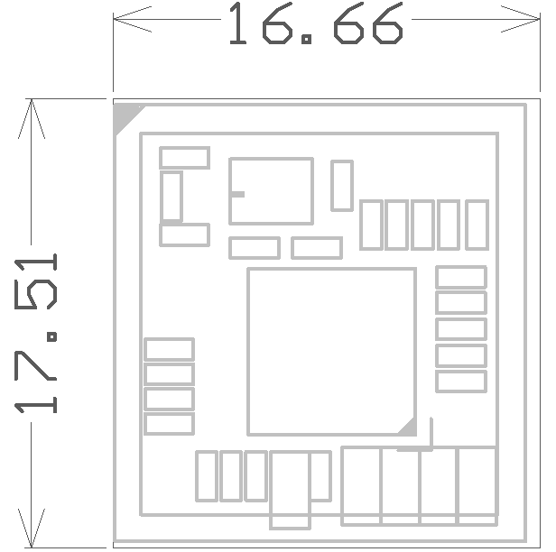
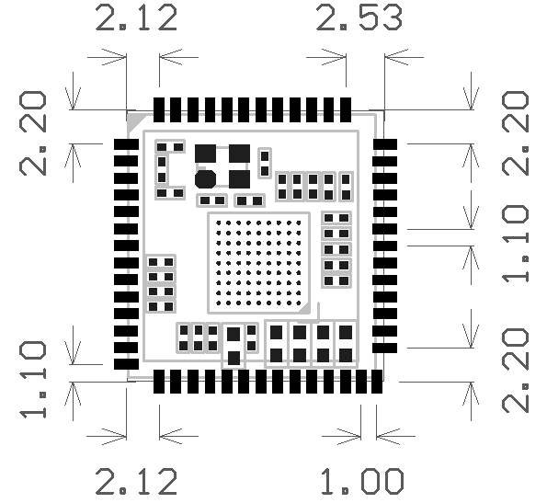

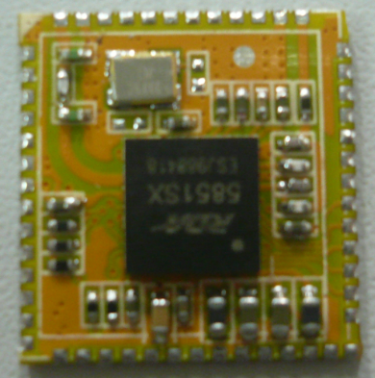
7.1.2 Module Image

7.1.3 Pins Drawing
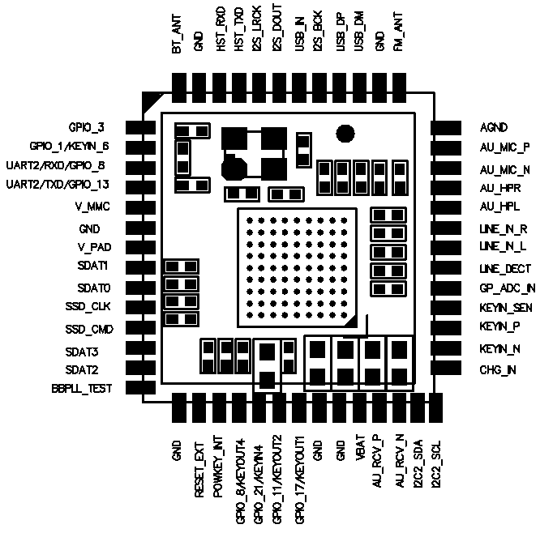

8. Reference Applications

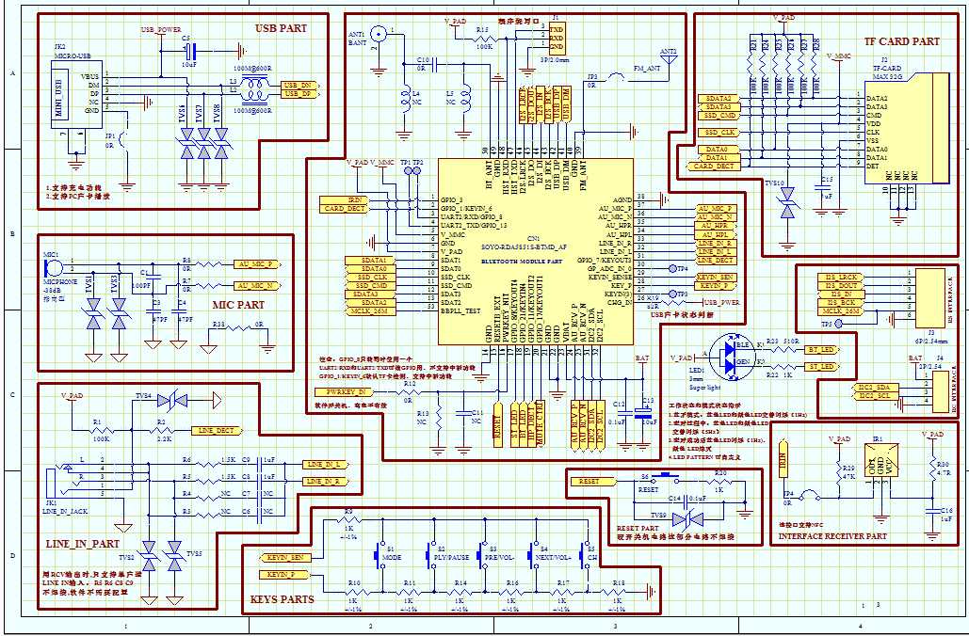

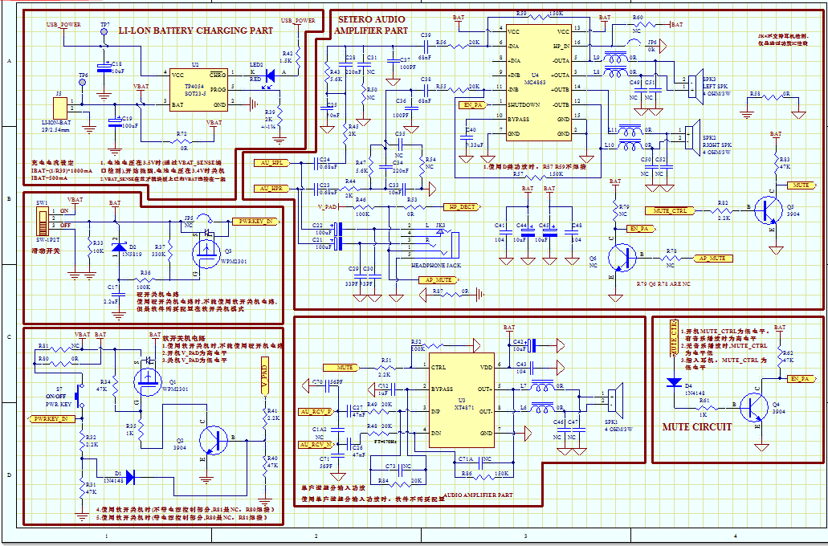

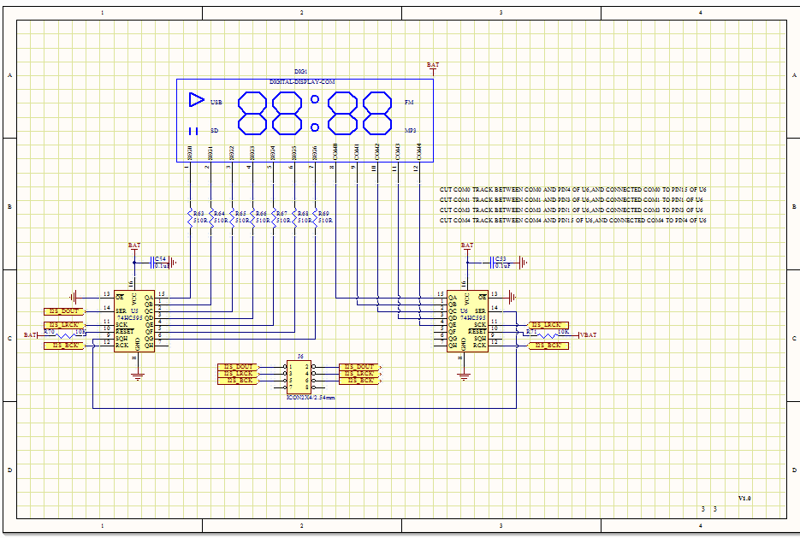

9 I/O pins
Pin No. | Definition | Remark
31 | GPIO_7/KEYOUT3 | Default line in detecting/Normal I/O, response to interruption, compound matrix keypad
19 | GPIO_11/KEYOUT2 | Default earphone detecting/Normal I/O, not response to interruption, compound matrix keypad
20 | GPIO_17/KEYOUT1 | Default external PA Standby, compound matrix keypad
18 | GPIO_21/KEYIN4 | Default BT_LED output, low electrical level valid, compound matrix keypad
17 | GPIO_8/KEYOUT4 | Default LED1 output, low electrical level valid, compound matrix keypad
1 | GPIO_3 | Default IR import/Normal I/O, Response to external interruption
2 | GPIO_1/KEYIN6 | Default Card detecting/Normal I/O, Response to external interruption, compound matrix keypad
3 | UART2_RXD/GPIO_8 | Default Uart port
4 | UART2_TXD/GPIO_13 | Default Uart port

Control Instruction
LED Indicator | Charge indicator | Bluetooth Indicator |  | Reserved LED Indicator , Self- defined
LED Indicator | Off when D6 full | GPIO_21 |  | GPIO_8
CARD | DATA | CMD | CLK |  | DECT
CARD | D0-D3 | SSD_CMD | SSD_CLK |  | GPIO_1
MUTE | Earphone Mute Control |  | Power Amplifier Mute Control
MUTE | GPIO_17( Low electrical valid)
OTHER | Self-Define based on ports

10. PCB LAYOUT
- Bluetooth antenna should be placed avoiding metal, because metal weaken antenna function. It is forbidden to place ground or wire under Bluetooth antenna.
- Metal component such as battery and chip should not overlap antenna. Module antenna is supposed to be placed at the edge of PCB.
- Signals and Bluetooth device are largely influenced by the environment. For instance, obstacles such as trees and metal absorb signals to a certain extent. And therefore transmission distance is often influenced in practice.
- As Bluetooth module fits in certain systems placing inside cases, metal cases should be avoided.

